



Implementation of the handle specific exceptions in Python
LAB MANUAL

Disclaimer: The content is curated from online/offline resources and used for educational purpose only
Implementation of the handle specific exceptions in Python

Objective:
- Learn how to handle logical errors using Python's try and except statements to manage exceptional cases that may occur during program execution.
- Learn how to handle exceptions in Python using the try-except block and how to specify different types of exceptions.

Problem Statement:
In this task, you are required to implement exception handling in Python, focusing on handling specific types of exceptions such as ValueError and ZeroDivisionError. The goal is to make the program robust and able to recover gracefully when it encounters an error.

Equipment Required:
- Install VS Code - https://code.visualstudio.com/download
- Download Python Installer File - https://www.python.org/downloads/
Prerequisites:
- Basic Computer Skills - Anyone starting to learn computer programming needs basic computer skills.
- Basics of control statements

Procedure:

Task 1: To implement the ZeroDivisionError and ValueError
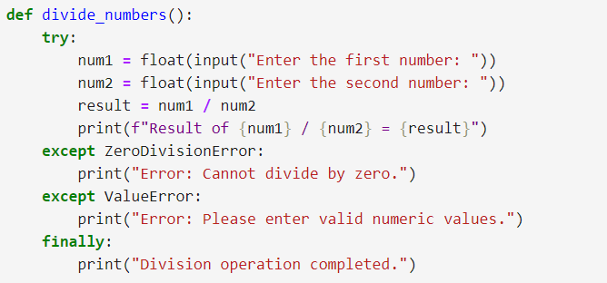
Output:

ZeroDivisionError,
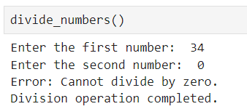
ValueError,
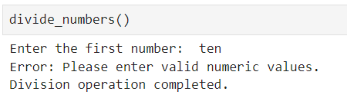
Final output,
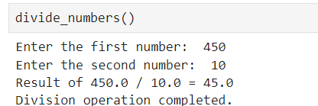

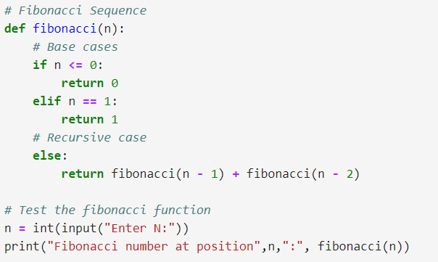
Output:
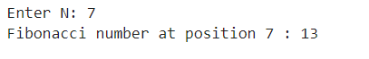

Both task1 & 2 are highlight the importance of recursion and its practical use in mathematical problems.

